Desayuno  Breakfast
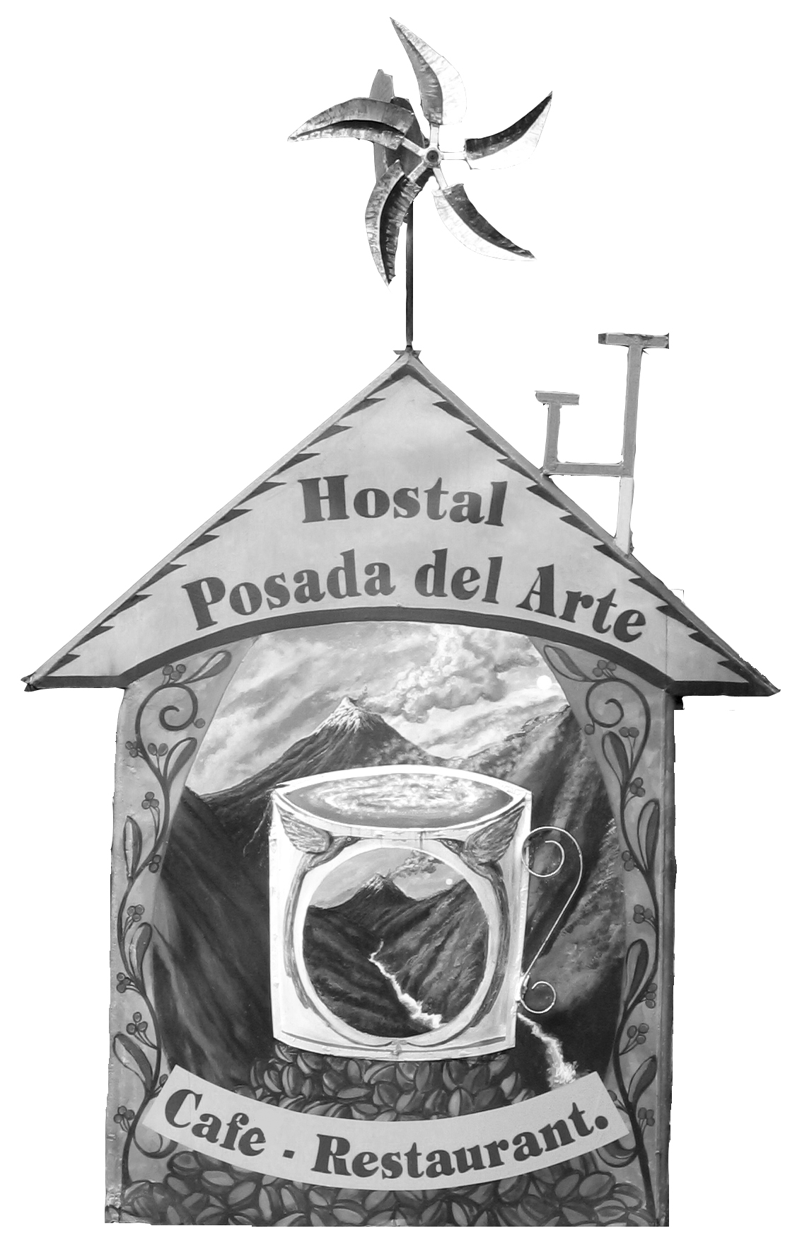
Especialidades de la Casa  House Specialties
La Posada del Arte
Acompañados de jugo de fruta natural:
Mora, naranja, piña, fresa, melon, sandia, papaya, maracuya o tomate.
Served with your choice of fresh squeezed juice:
Blackberry, orange, pineapple, strawberry, cantelope, watermelon,
papaya, passion fruit or tree tomato.

Chimborazo

Muesli
Con té, café o chocolate caliente. Canasta con tres tipos de pan.
Queso, mantequilla, mermalada
Muesli
With tea, coffee or hot chocolate. Basket with three kinds of bread.

Cheese, butter and jam
4.00

Altar
Ensalada de frutas
Con granola, yogurt y miel de pasíon. Té, café o chocolae caliente.
Canasta con tres tipos de pan. Mantequilla, queso, mermalada.
Fruit Salad
With granola, yogurt, honey of passion fruit. Tea, coffee or hot chocolate.
Basket with three kinds of bread, butter, cheese, jam.
4.00

Cotopaxi
Omelette
Al gusto. Selección tres ingredients:
Queso, jamón, cebolla, tomate, verduras, champiñones.
Té, café o chocolate caliente, canasta con tres tipos de pan.
Queso, mantequilla, mermalada.
Omelet
Selection of three ingredients:
Cheese, ham, onion, tomato, vegetables, mushrooms.
Tea, coffee or hot chocolate, basket with three kinds of bread.
Cheese, butter, jam.
4.00

Tungurahua
Pancake
Con ensalada de frutas, yogurt, granola, miel, té,
café o chocolate caliente.
Pancake
With fresh fruit salad, granola, yogurt, honey of passion fruit,
Tea, coffee or hot chocolate.
4.00

Desayuno  Breakfast

La Posada del Arte

Bebidas Calientes  Hot Drinks
Té o café negro  Tea or black coffee | 1.00
Café con leche  Coffee with milk | 1.00
Chocolate Caliente  Hot chocolate | 1.50

Bebidas Frias  Cold Drinks
Jugos  Juices | 1.00
Chocolate helado  Chocolate milk | 1.80
Batidos de frutas con yogurt o leche  Milkshakes | 1.80

Huevos  Eggs
Omelette al gusto | 2.00
(Tomates, queso, cebolla, jamón, championes o verduras)
Omelette as you like it
(Tomato, cheese, onion, ham, mushrooms or vegetables)
Revueltos  Scrambled | 1.50
Duros o tibios  Hard boiled | 1.20
Fritos  Fried | 1.50
Rancheros  Rancheros  Frijoles refritos, guacamole, huevos fritos, arroz y ají, tostitos  Refried beans, guacamole, fried egs, rice and hot sauce | 4.00

Pancakes | 3.00
Al gusto
Un grande o dos pequeños con 1-3 ingredientes:
Miel de pasión, mermelada, bananas, granola, yogurt, chocolate, frutas o helado.
Pancakes
As you like them
One large or two small pancakes with 1-3 ingredients:
Honey of passion fruit, jam, bananas, granola, yogurt, chocolate syrup, fresh fruit or ice cream.

Ensalada de Frutas  Fruit Salad | 2.30
Granola con Leche  Granola with milk | 2.00
Granola con yogurt  Granola with yogurt | 2.20
Porción de pan, queso, mantequilla y mermelada  Serving of bread, cheese, butter and jam | 2.50

